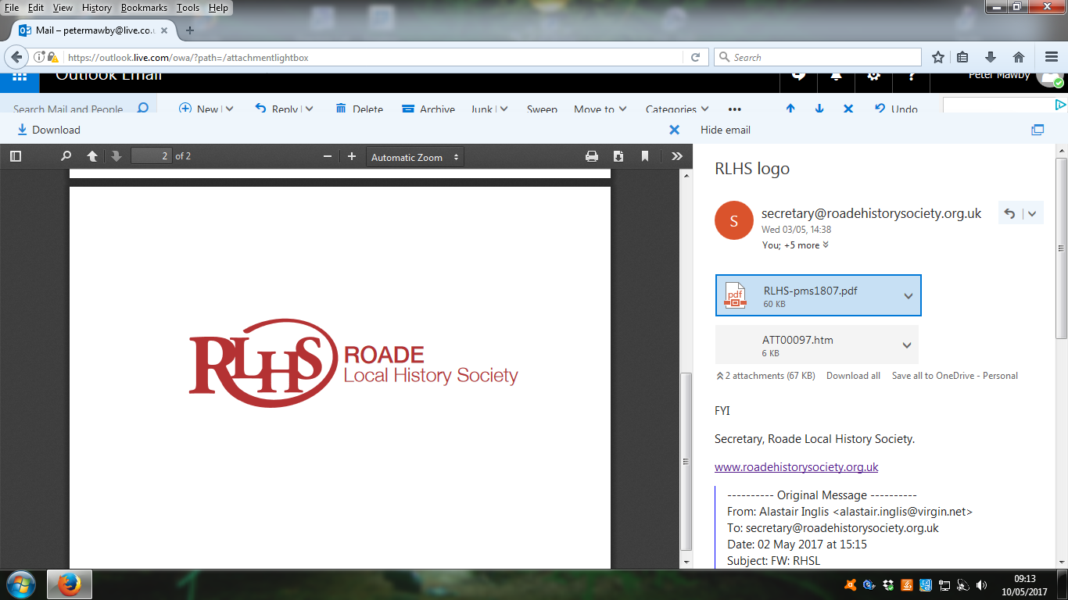

[www.roaderemembered.org.uk](http://www.roaderemembered.org.uk)

MEMBERSHIP APPLICATION FORM

Name …………………………………………………………………….

Address …………………………………………………………………….

…………………………………………………………………….

…………………………… Postcode……………………….

Telephone number ………………………………………………….

Mobile number …………………………………………………………… 

Email address ………………………………………………………………….. 

(all capitals please)

GDPR requires us to ask you to confirm by which methods we may communicate with you by ticking the appropriate box(es) above. Email is our preferred means of communication. Your email address will not be circulated, sold or otherwise divulged to anyone.

Our programmes and any changes can be found on our website

We welcome your assistance with any projects undertaken by the Society. Do you have any skills or interests that may help us?

Please tick as many boxes as you can, this will ensure your Society thrives.

Document research Archiving  Oral History 

Photography  IT  Publications 

Helping at meetings and/or events 

Please complete this form and post or deliver it to The Secretary, RLHS, 22 Hartwell Road, Roade, NN7 2NU, with your annual subscription of £7 cash/cheque payable to Roade Local History Society or bring to one of our meetings/events. Thankyou